Note template
For every problem you solve, write these 5 things — keep it under 10 lines total:
- Problem pattern — What category is this? (sliding window, two pointers, DP, BFS, etc.)
- The trigger clue — What in the problem statement told you to use this pattern? (e.g., "subarray of size k" → sliding window)
- Core intuition — 1-2 lines explaining the idea, not the code (e.g., "maintain a window, shrink from left when condition breaks")
- Edge cases — What tricky cases did you miss or almost miss?
- "What I learned" — One line on what was new or non-obvious
Paste a screenshot of the problem then answer this 5 question of that problem

Remove Duplicates in-place from Sorted Array
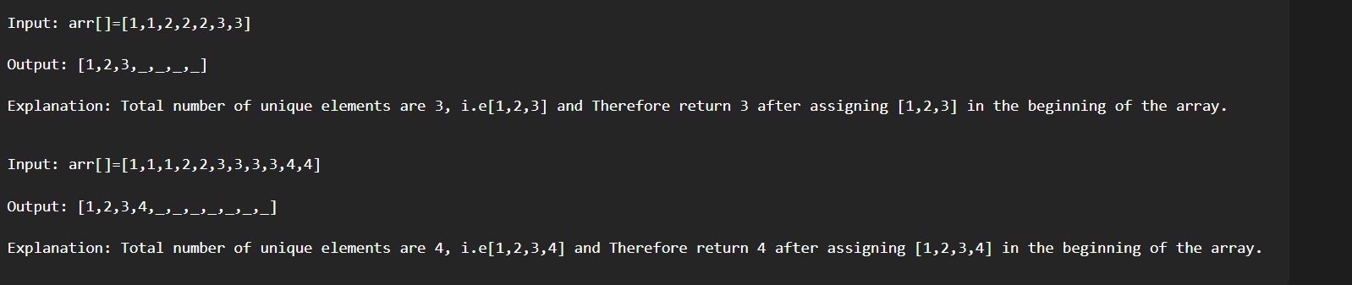
My first thought is why cant we use set and put all the unique elements in the set.
Time and space complexity will be O(n) and O(n).

If u do It in place then it the time and space will be O(n) and O(1)

This problem pattern is two pointers. We are using two pointers because we need to compare the two values and if the the value is different then replace… Since the array is sorted the element which went behind cant come future and we only need to return the count of unique elements.
In this problem there is no swapping because we don’t need entire array we only need unique elements so we can loose the elements here.
In this problem need to take j first then i and not i and j.
i will keep moving and j will only move if elements are not same.
In short one pointer will move only if second pointer finds a different elemet.

Left Rotate the Array by One
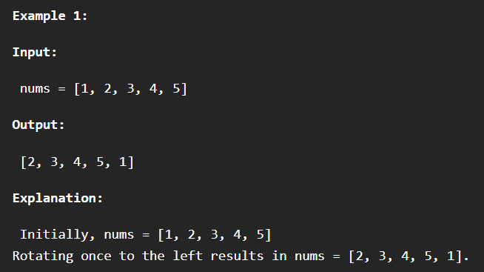

First I thought of using shift and push. Why shouldn’t I do that.
shift() | Removes index 0, then re-indexes every remaining element (index 1→0, 2→1, ...) | O(n)
push() | Just appends to the end, no reindexing needed | O(1)
Total Time | Dominated by shift() | O(n)

Rotate array by K elements
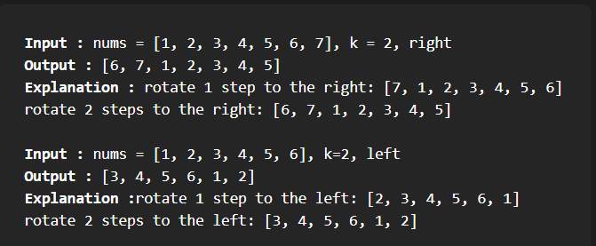

1st approach = temp array
The pattern is two pointers.
The number k can be bigger then the length of the array so to fix that we can do k=k%n where n is the length of the array.
I need to store the k elements in the temp array.
Move the remaining elements to one side
Then insert that temp array into the main array after replacing the position of the rest of the array.
Mistake : While inserting the temp to array. Careful because the length of temp is just k%n and length of array is n u might add undefined into array.
So the loop of inserting should start from 0 to k
Complextity analysis
The time is O(n) and space is O(n).

2nd approach = In place replace
Reverse the array. Then reverse (0,k-1) and then reverse (k,n-1) this will reverse the array k times.
Write a reversing function using while loop. Destructuring swap.

Move all Zeros to the end of the array
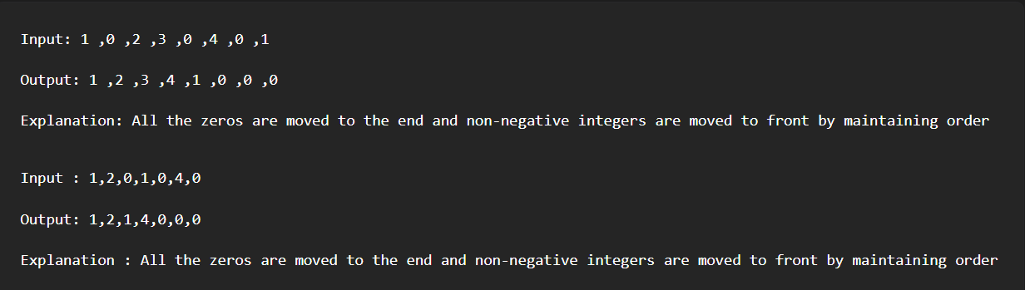
Two pointers pattern
Need to find first zero position and assign it to j.
J will be -1 at the start
i will start from j+1;
j will always be at the index of value 0.

Union of Two Sorted Arrays
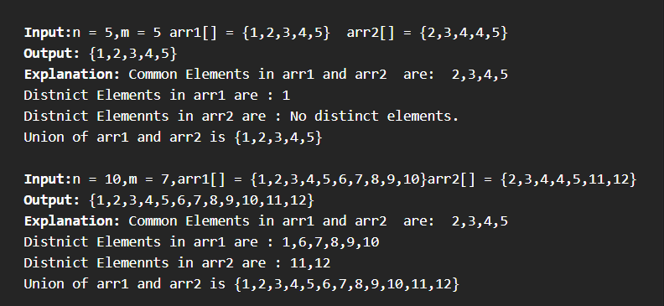
- check which element is smaller or higher.
- if arr1 element is smaller then put element 1 in the array and increase the index then if arr2 element is smaller then put element of arr2 in the result array and increase that array index. If both of them are equal the put just one and increment both index
- if any of the array found smaller then other then check
result.length === 0 this is the backup check for result[result.length - 1] on an empty array gives undefined.
- Why result[result.length-1] Since both arrays are sorted, duplicates are always adjacent.
- so along with the check of with element is smaller u need to check if the element is repeated.
- Missed edge case: After all the checks there might be extra elements in either of the arrays so u need to make sure to add all the remaining element of both the array.

